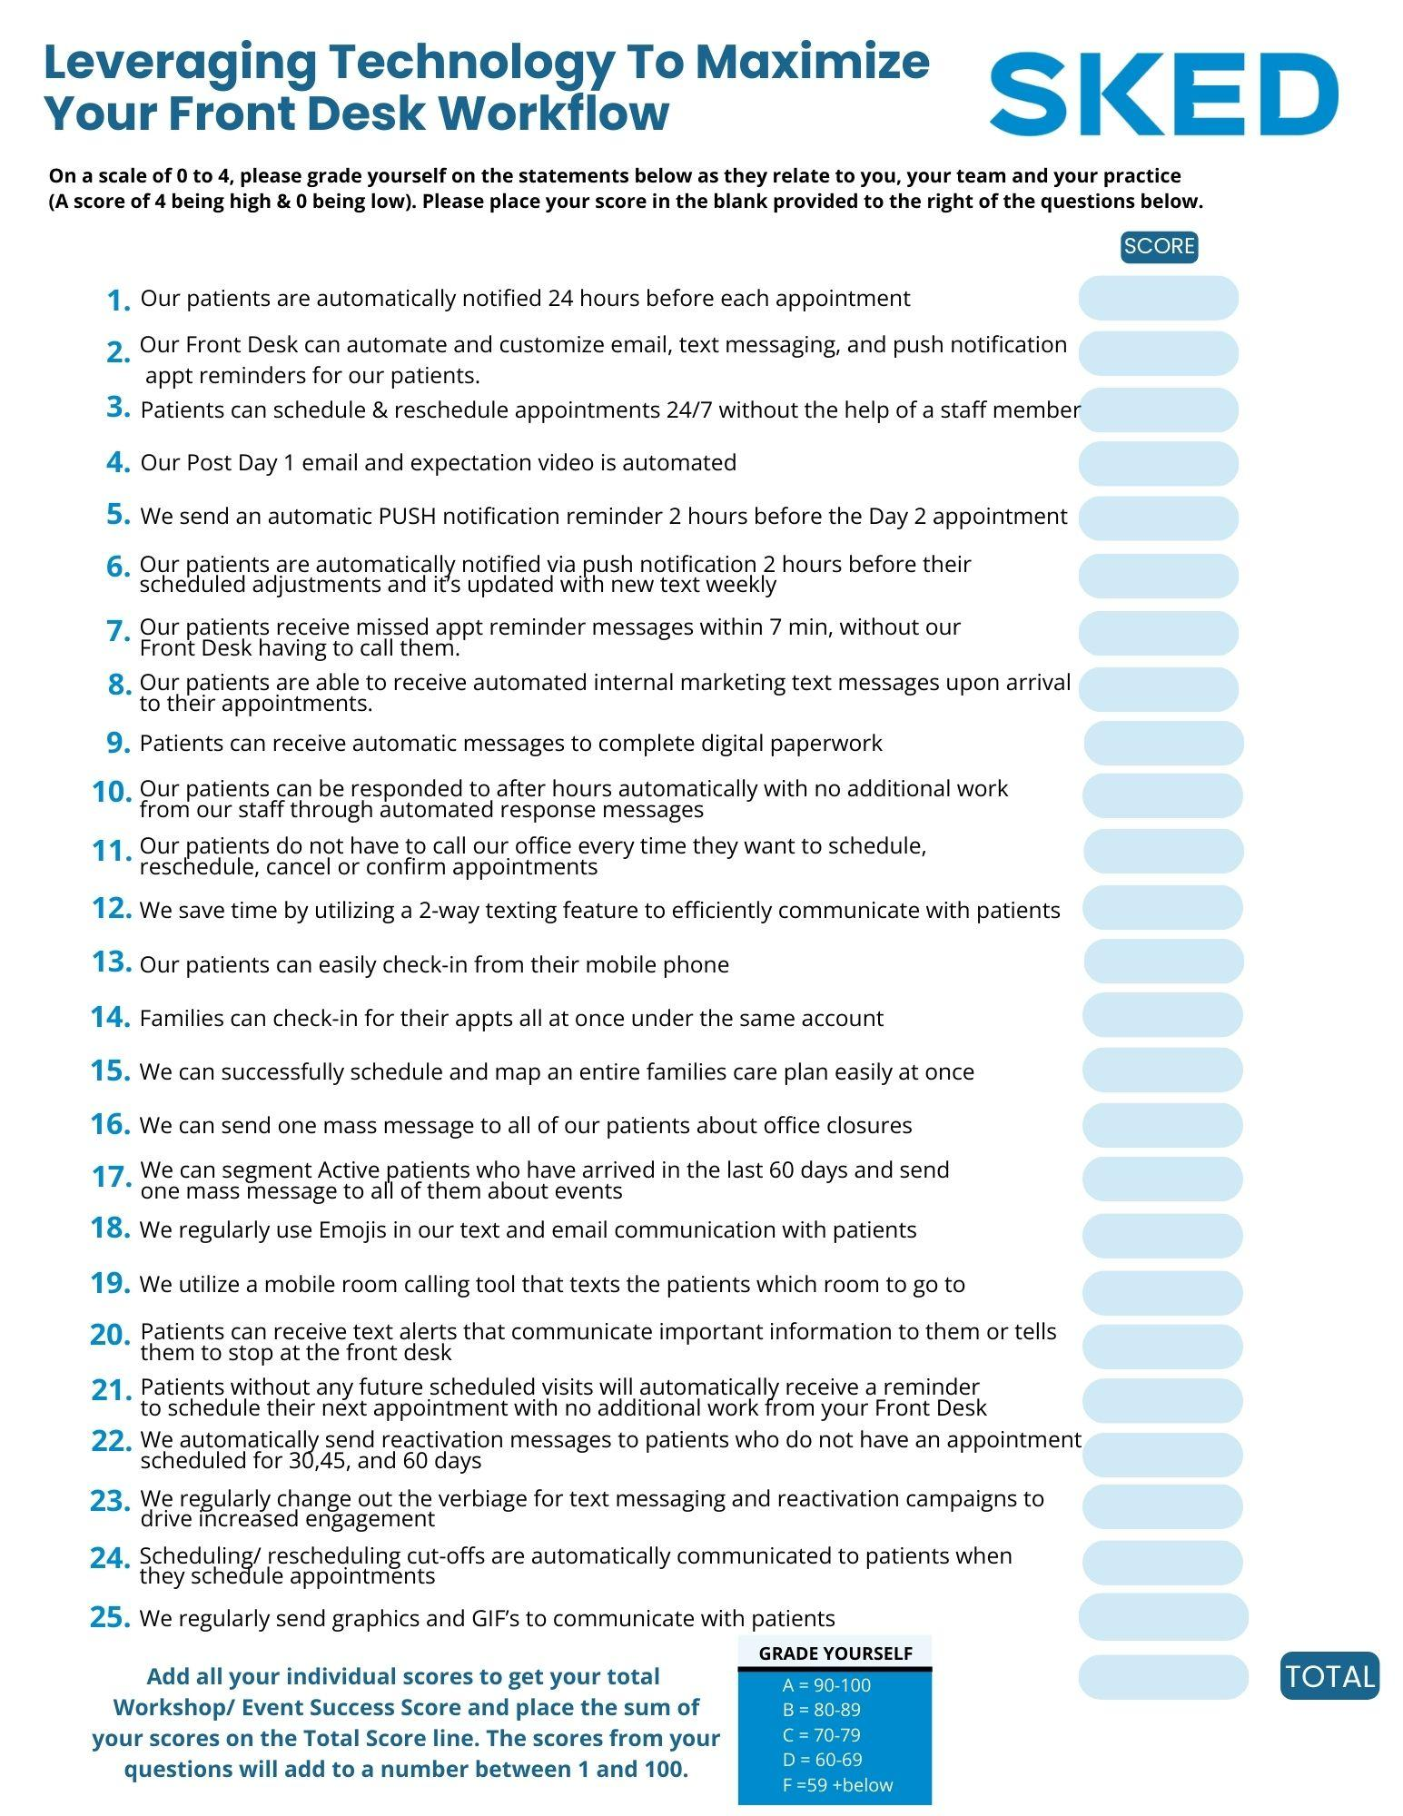

Do you know your front desk score?

Have you ever wondered how streamlined your front desk is? Or why your team spends so many hours on the phone? If so…this resource is just for you!

SKED is offering you a FREE copy of this scorecard, “Leveraging Technology to Maximize Your Front Desk Workflow” so that you and your team can complete this assessment together. Use this amazing resource to evaluate your technology and effectiveness now and revisit in the future to gauge progress.

CLICK HERE TO ACCESS THIS FREE RESOURCE!

We’d love to hear your feedback on your score and what steps you’re planning to take in order to increase your efficiency at the front desk. Revisit this scorecard every month to see how much progress you’ve made and hold your team accountable.

In Health,
Dr. Erik Kowalke
CEO/Founder
Higher Health Chiropractic and SKED

